How to renew your membership online
You will need to do this on the MAIN eBooking Site, NOT on the phone App. You can get there two ways.
- Follow the link to the eBooking website eBookingOnline.net/box/304 OR
- From your Phone App, Click on the 3 line Hamburger Icon the top left of the screen and Click on “Main Site”
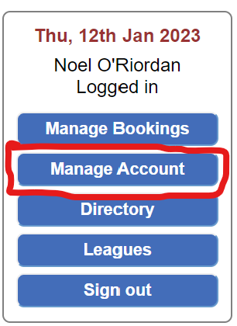

Renew your Membership on the Membership Renewal Tab
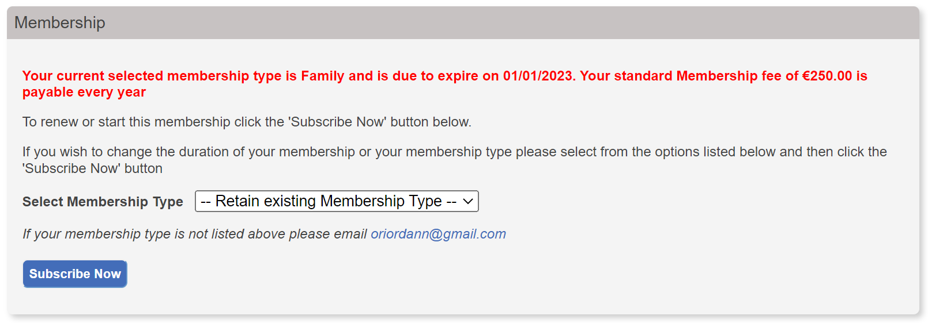

You have an option to retain your current Membership Type or change to a new Membership Type for the next year. E.g. Family changing to Couple or Individuals
Select your Membership Type from the drop down list
and Click on “Subscribe Now”
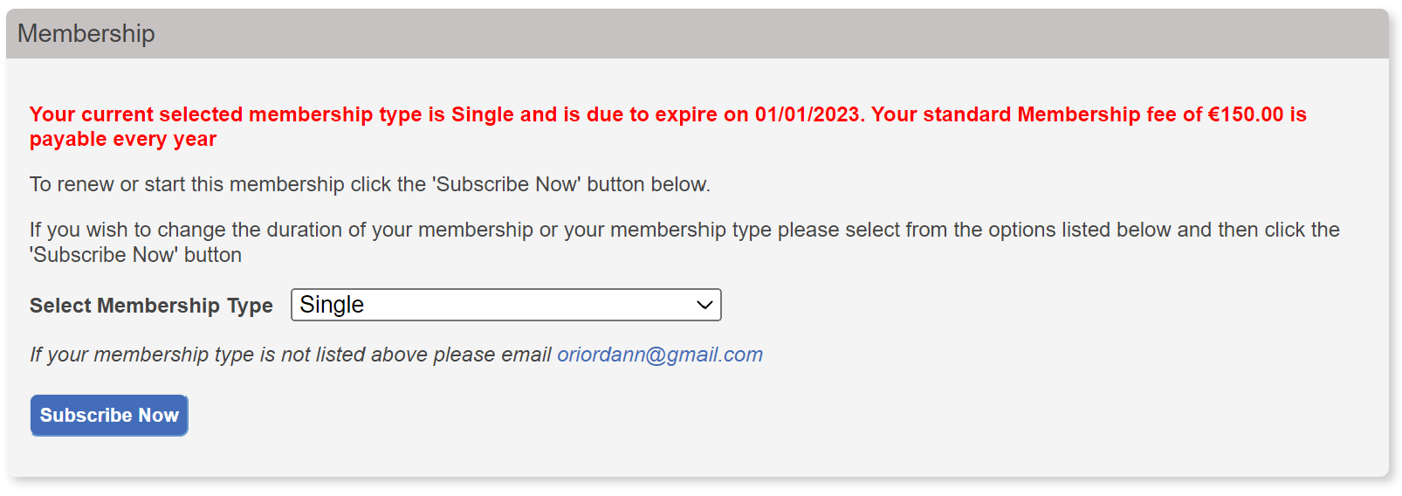

Just enter the Card details for the card you wish to use for your Membership Renewal.
Enter card details
- Your name, as it appears on your Card
- Your 16 digit Card Number
- Your Card Expiry Date 12/23
- Your CVC number, that’s the last 3 digits on the back of your Card
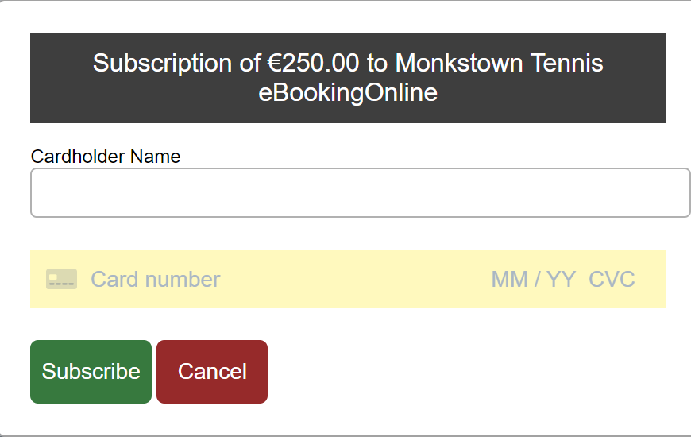
Then Click on Subscribe

After a few minutes the eBooking message will change to show you details of your subscription type, your recurring Fee, the last 4 digits of your Credit Card and when your next payment is due.
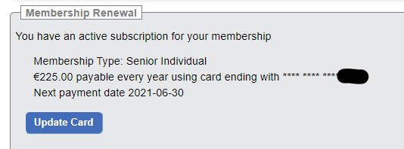

IMPORTANT: Membership of Monkstown is a Subscription service. Membership is for a calendar year with automatic renewal date of the 01/01/2024. If you decide not to renew your membership, please contact monkstowntennis@yahoo.ie in advance of your renewal date and we will cancel your subscription.
REMEMBER: If you are changing membership type from Family to Couple or Couple to Individual, Their membership will continue until their current expiry date. If any of the members wish to continue their own membership, they will need to follow this renewal process before their membership expiry date.
Hope this helps 😄
Monkstown Tennis Club

